**Jitsu Installation and Configuration Report**

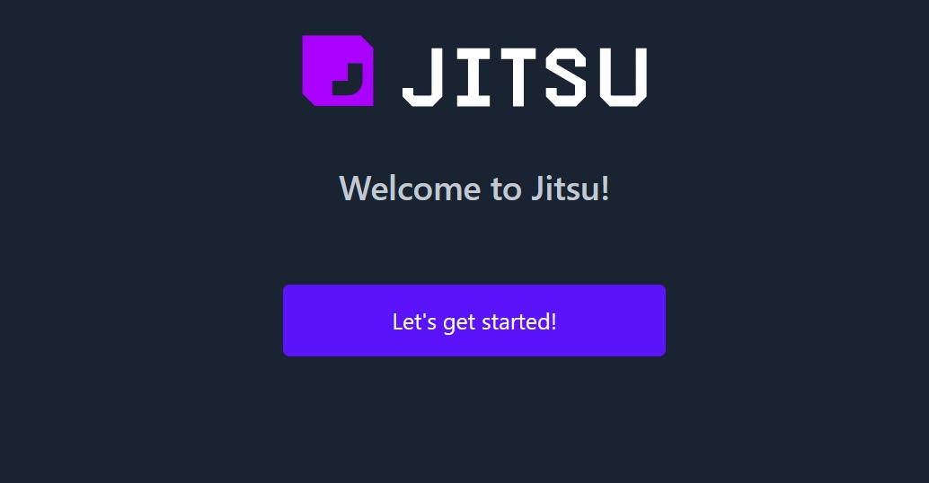

# **Introduction**

## **Objective**

The objective of this report is to document the step-by-step process of setting up Jitsu on a local machine, including creating a Jitsu instance, adding a site, adding a warehouse destination, and connecting the site to the destination.

# **Jitsu Installation**

## **Clone the Jitsu Repository**

git clone https://github.com/jitsucom/jitsu.git

cd jitsu

## **Install Dependencies**

npm install

## **Configure Jitsu Instance**

Follow the instructions on the Jitsu website to create a Jitsu instance.

Make note of the instance URL.

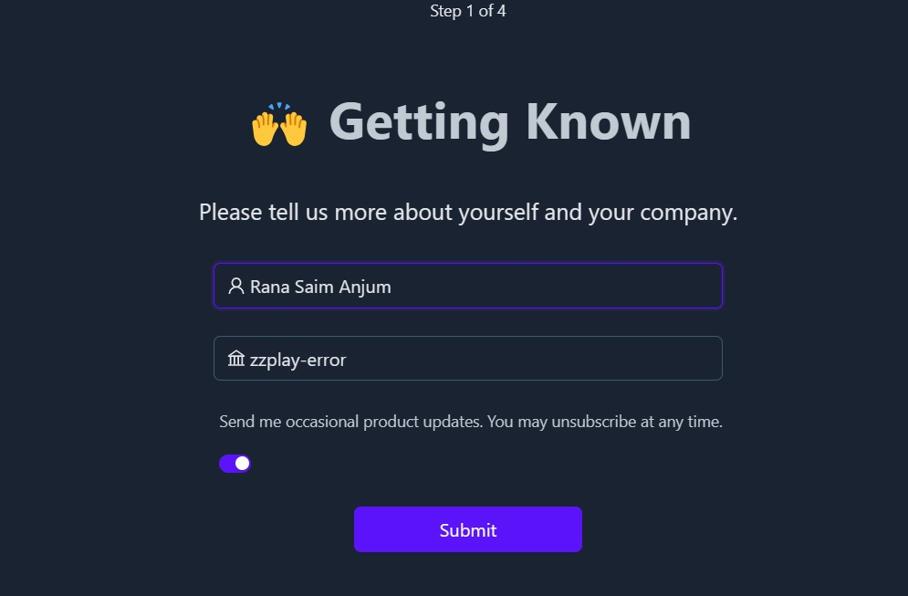

# **Adding a Site**

## **Open Jitsu Dashboard**

Access the Jitsu dashboard.

## **Add Site**

Navigate to "Sites" » "Add Site" in the dashboard.

Fill out the required information.

Optionally, add a custom domain.

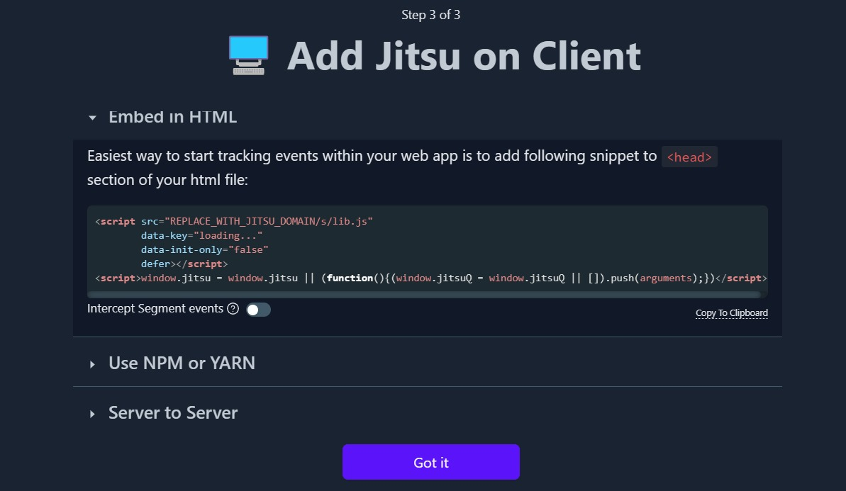

# **Adding a Warehouse Destination**

## **Go to Destination**

In the Jitsu dashboard, go to "Destination" » "Add Destination."

## **Select Destination Type**

Choose a supported destination type.

Fill out the required information.

# **Connecting Site and Destination**

## **Navigate to Connections**

In the Jitsu dashboard, go to "Connections" » "Connect site and destination."

## **Choose Source and Destination**

Select the source and destination to connect.

## **Set Up Connection Options**

Configure additional connection options (e.g., Batch or Stream mode for data warehouse destinations).

## **Add Functions to Processing Pipeline**

Optionally, add built-in or user-defined functions to the processing pipeline for the specific connection.

# **Verification**

## **Verify Setup**

Check the Jitsu dashboard to ensure the site and destination are connected without errors.

## **Data Processing**

Verify that data is being processed according to the configured settings.

# **Conclusion**

## **Summary**

In conclusion, the setup of Jitsu on the local machine involves cloning the repository, installing dependencies, configuring a Jitsu instance, adding a site, adding a warehouse destination, and connecting the site to the destination. The verification steps ensure that the setup is successful, and data processing is functioning as expected.

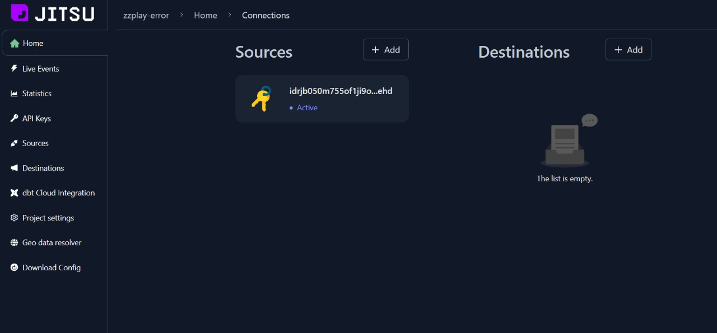

## **Next Steps**

Refer to the Jitsu documentation for more details on core concepts, troubleshoot any encountered issues, and explore additional features.